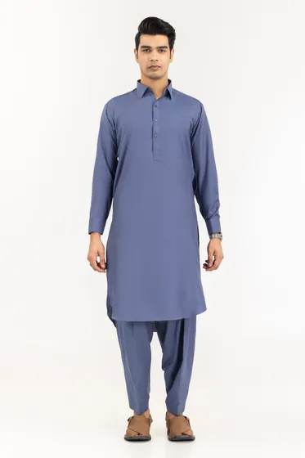[**PRODUCT DETAILS**](https://www.gulahmedshop.com/opus-iconic-unstitched-fabric-blended-lf#description)

Craft your wardrobe of essentials with the finest fabrics of GulAhmed Men’s Collection.

* Premium Fine Wash & Wear Fabric
* 4.5 MTR Suit Width 54 in

|  |  |
| --- | --- |
| More Information | |
| **NEW ARRIVALS:** | No |
| **GENDER:** | Men |
| **DISCOUNT PERCENTAGE:** | 31% to 40% |
| **SHIRT FABRIC:** | Wash & Wear |

Opus Iconic Unstitched Fabric Blended-LF

SKU

MEN-FABRIC-331623 -P

IN STOCK

PKR 3,411